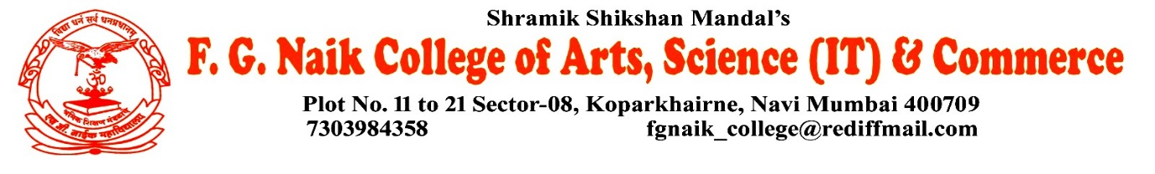

NSS UNIT
VANDE MATARAM AT COLLEGE
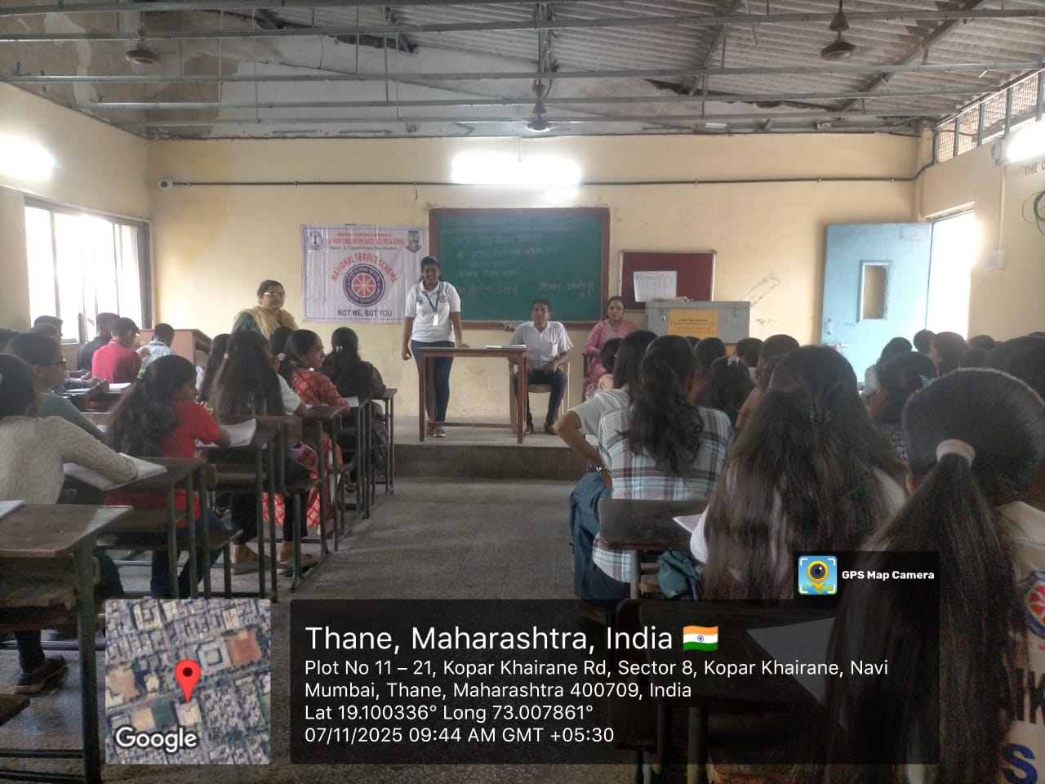

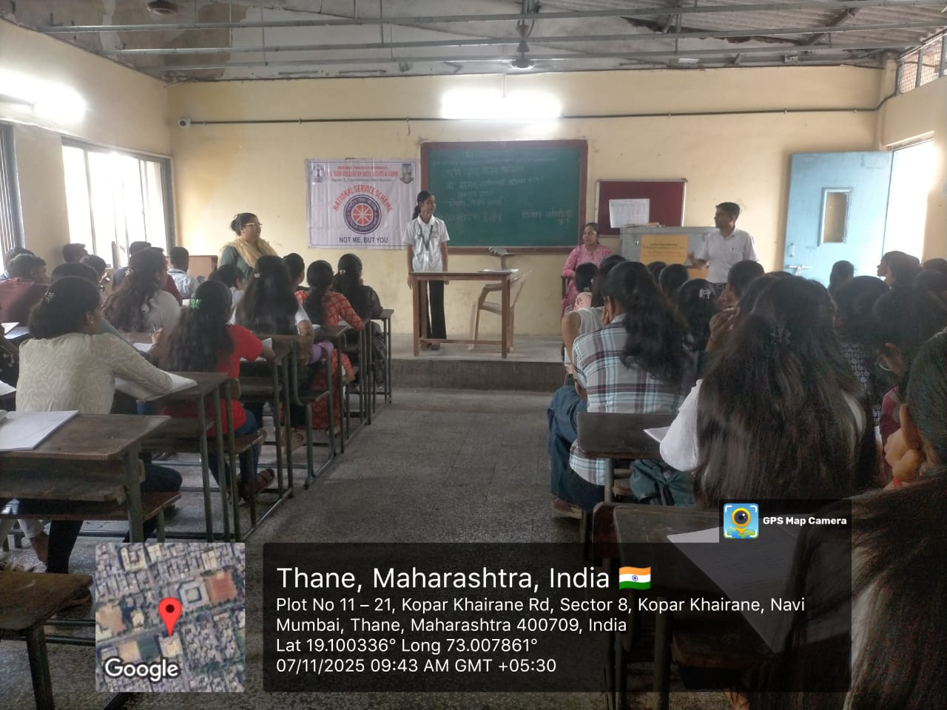
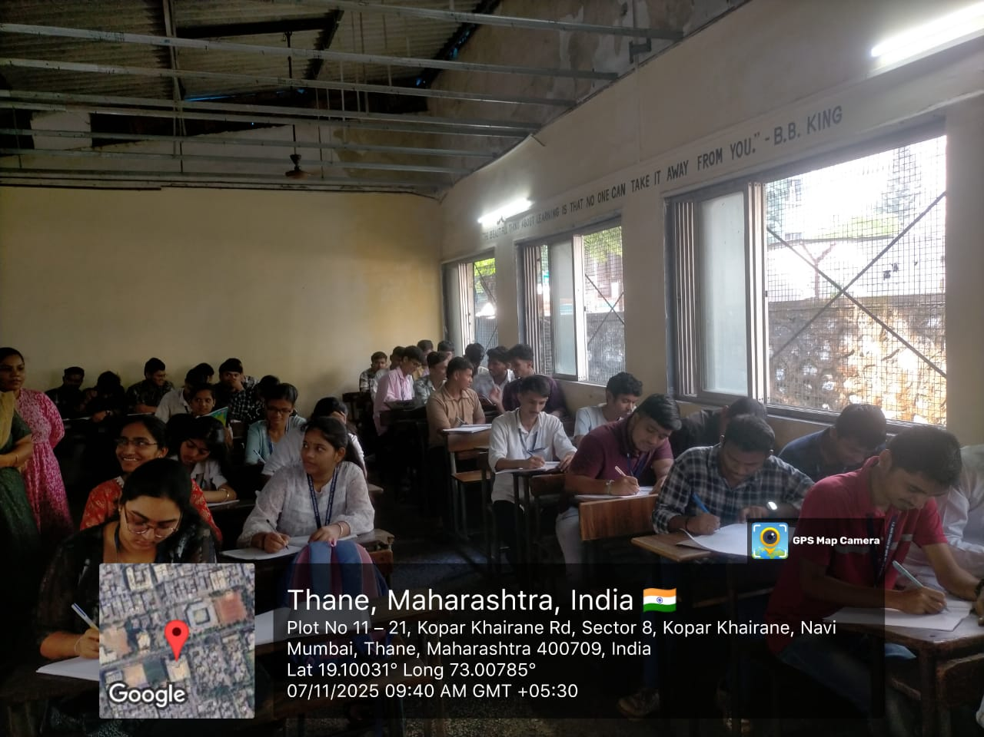

OBJECTIVE OF PROGRAM: To instill a sense of patriotism and national pride among students by honoring the spirit and values of the national song Vande Mataram.
DATE: 07/11/2025
LOCATION: F.G NAIK COLLEGE
PARTICIPATING STAFF: All the NSS volunteers, teaching and the non-teaching staff of the college.
NUMBER OF VOLUNTEERS PARTICIPATING: 24
The NSS Unit organized the Vande Mataram program at the college to promote unity, patriotism, and respect for the nation. The event emphasized the historical and cultural significance of Vande Mataram and its role in inspiring India’s freedom struggle.
Students actively participated by singing Vande Mataram with devotion and discipline. The program created a sense of national pride and encouraged students to uphold the values of unity, dedication, and service to the nation.
PROGRAM DETAILS: The program commenced with a formal gathering, creating a respectful and patriotic atmosphere on the campus.
The NSS Unit successfully conducted the Vande Mataram program at the college, strengthening feelings of unity, respect, and patriotism among students.

NSS IQAC
PROGRAM OFFICER CO-ORRDINATOR I/C PRINCIPAL

